==================================================================ResolveNow Online Complaint Management System
"Empowering users to register and resolve complaints seamlessly"
===================================================================
Project Title : ResolveNow – Your Platform for Online Complaints
Category: Full Stack Development with MERN
Team ID: LTVIP2025TMID56856
Team Size: 4
Team Members:
- Bola Hari Kethan
- Battula Dwarakamai
- Boddukuru Lokesh
- Kota Bhargavi

Prepared by: Bola Hari Kethan
Full Stack Developer
Submitted to:
SmartInternz | AICTE | RISE Krishna Sai Prakasam Group Of Institutions




Project Overview
Purpose:
ResolveNow is an online complaint registration and management system that simplifies the complaint handling process for users, agents, and admins. It aims to empower organizations to handle customer complaints efficiently, ensuring transparency and quick resolution.
Features:
- User registration and secure login
- Complaint submission with detailed fields
- Track complaint status and updates
- Chat window to communicate with assigned agent
- Admin dashboard to monitor and assign complaints
- Agent dashboard to manage assigned complaints
- Real-time notifications
- Security and confidentiality with authentication and access controls

Architecture
Frontend:
- Built with React.js
- Uses HTML, CSS, JavaScript, Bootstrap, and Material UI
- Axios for API communication
- React Router for routing
- Organized reusable components and pages
- Real-time UI updates
Backend:
- Node.js + Express.js server
- RESTful APIs for CRUD operations
- Authentication and middleware
- Routes: user, agent, admin, complaints
Database:
- MongoDB (NoSQL)
- Collections: user_Schema, complaint_schema, assigned_complaint, message
- Mongoose ODM for schema definitions and interactions
- Secure storage and efficient queries
Additional:
- Chat system uses complaintId and userId references
- Real-time updates and status changes handled via API

Setup Instructions
Prerequisites:
• Node.js (v18+)
• MongoDB (local or Atlas)
• Git
Installation:
- Download the project from Google Drive: Click Here --- Drive Link
- Extract the ZIP file (if zipped) and navigate into the folder.
- Install frontend dependencies:
cd frontend
npm install
- Install backend dependencies:
cd ../backend
npm install
- Create a .env file inside /backend:
MONGO_URI=your_mongodb_connection_string
JWT_SECRET=your_secret_key

Folder Structure
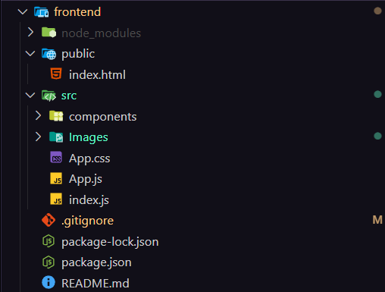
Frontend (React):
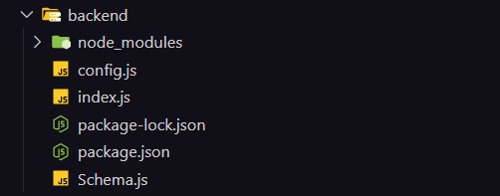
Backend (Node.js):
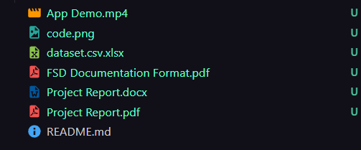
Other:
Running the Application
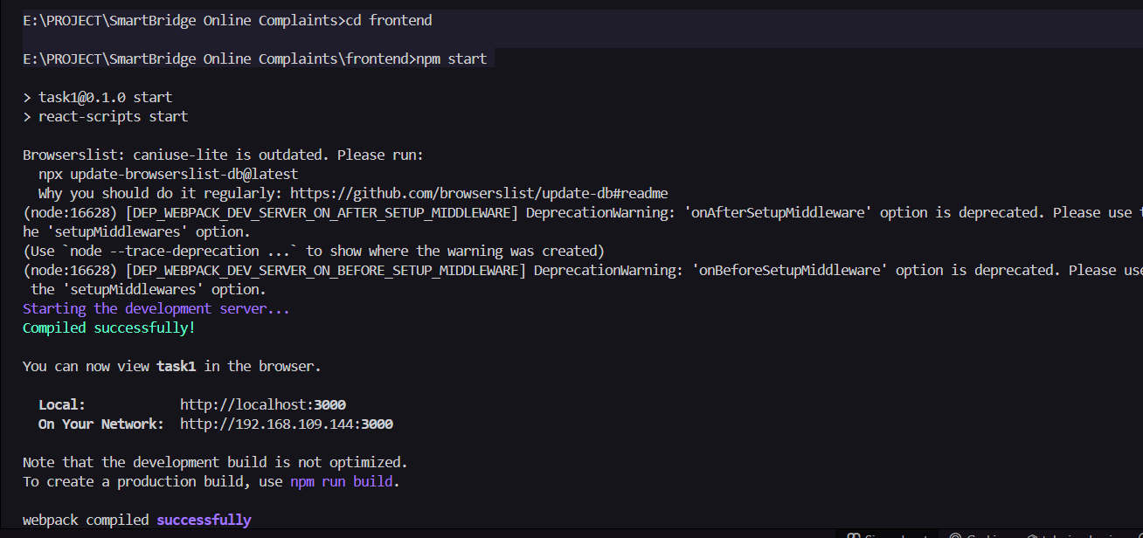
Frontend:
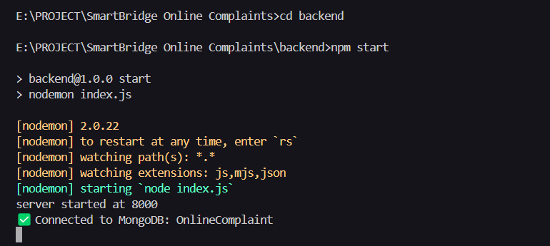
Backend:
Open browser: http://localhost:3000
________________________________________
API Documentation (Example)

POST /api/register
• Register a new user
Body:
{
"name": "Bola Hari Kethan",
"email": "ketan@gmail.com",
"password": "mysecurepass"
}

POST /api/login
• Login user
Body:
{
"email": "ketan@gmail.com",
"password": "mysecurepass"
}

POST /api/complaints
• Submit new complaint
Body:
{
"userId": "123",
"description": "Street light not working in Gaddalagunta Palem",
"address": "2-1-38, Water Tank degara, Gaddalagunta Palem, Ongole",
"status": "pending"
}

GET /api/complaints/123
• Get complaints submitted by user Bola Hari Kethan

PUT /api/complaints/456
• Update status of complaint (e.g., mark as resolved)
Body:
{
"status": "resolved"
}

(* Full detailed list available in final version *)

Authentication
- JWT-based authentication
- Passwords hashed using bcrypt
- Role-based access: User, Agent, Admin
- Auth middleware to protect routes
- Secure token storage

User Interface
- Landing page with login/register options
- Dashboard to submit complaints and track status
- Admin dashboard to assign/manage complaints
- Agent dashboard to update and resolve complaints
- Built-in chat window to communicate with agent
- Responsive design with Bootstrap and Material UI

Testing
- Manual testing of flows
- API testing with Postman
- Validation of database operations with MongoDB Compass
- (Optional) Plan to add Jest for unit testing

Screenshots or Demo
Project demo video :
https://drive.google.com/file/d/1RRF34M8DiE24LamnBjGNdvaJyxojTlgx/view?usp=sharing

OUTPUT SCREENSHOTS
- Home Page
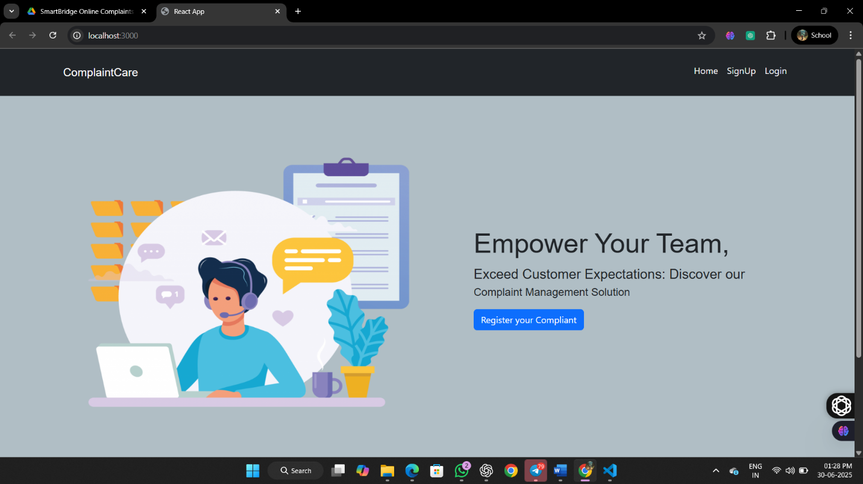

- Registration For OnlineComplaint
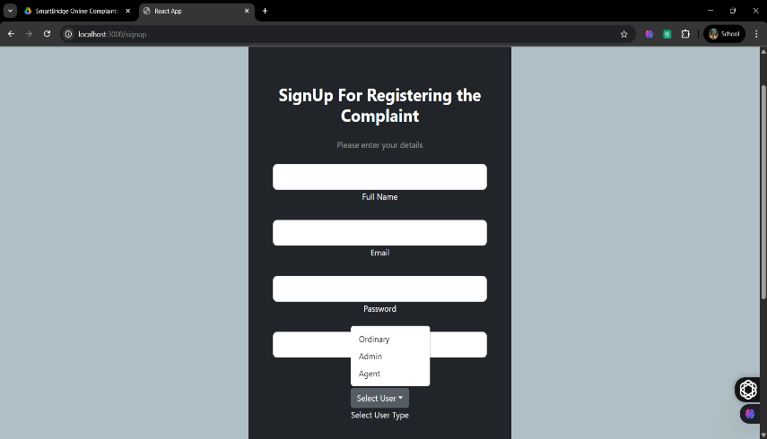
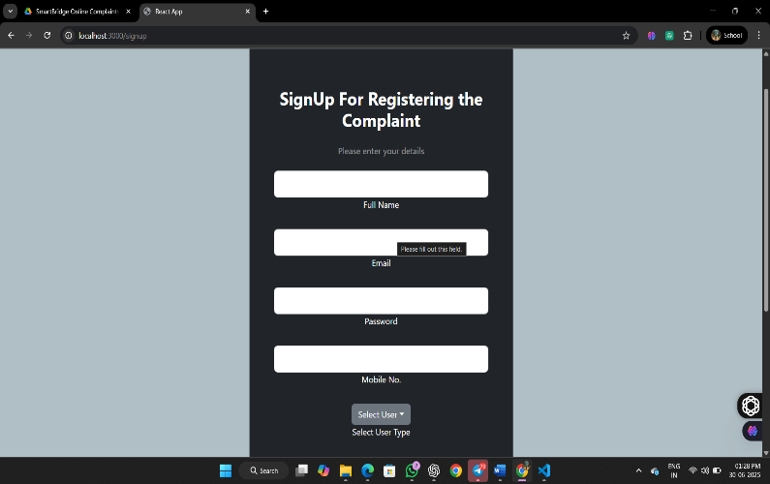

- User Login : To raise a Complaint
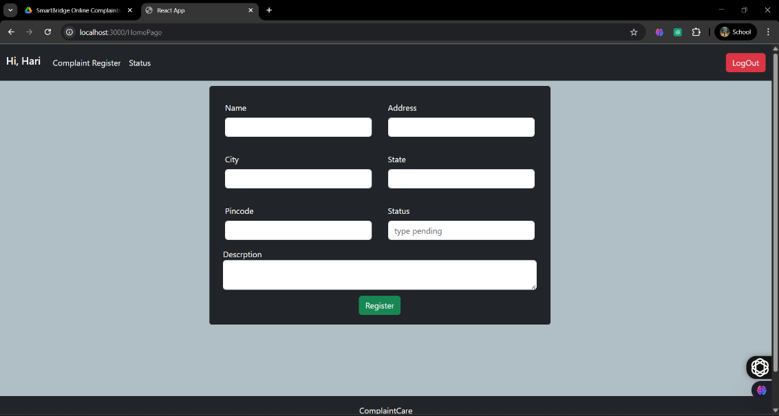

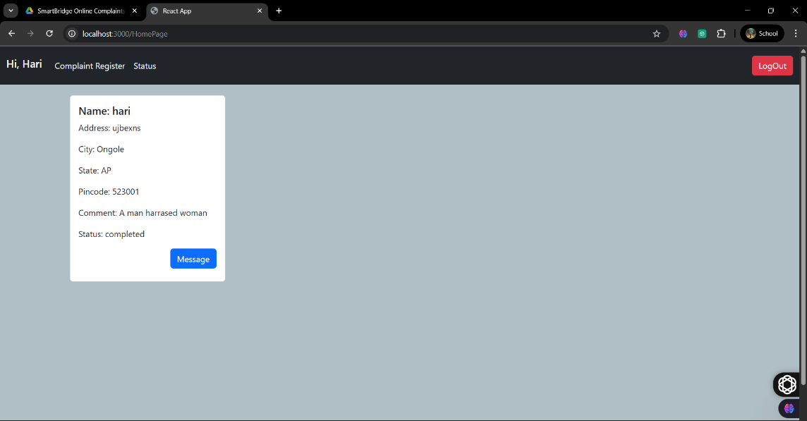
- Agent Login
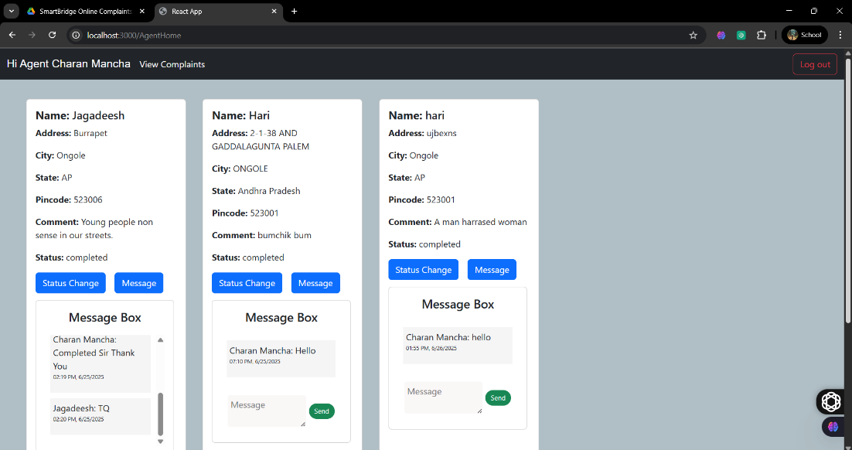

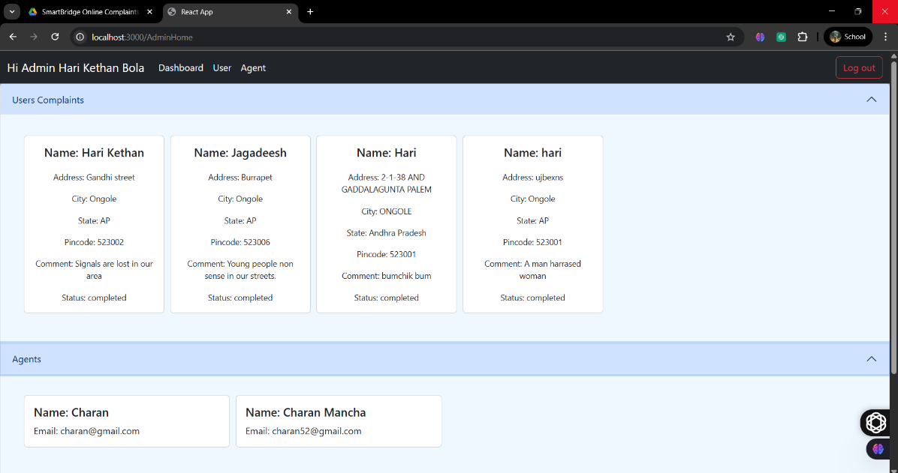
- Admin Login

Known Issues
- No email/SMS notifications yet
- Basic validation on some forms
- Password reset feature missing

Future Enhancements
- Add real-time notifications via socket.io
- Email/SMS alerts on status change
- Analytics dashboard for admin
- Mobile app version using React Native
- Improve chat experience with file attachments

Technical Details
- Frontend: React.js, Bootstrap, Material UI, Axios
- Backend: Node.js, Express.js, REST API
- Database: MongoDB, Mongoose
- Version control: Git & GitHub
- Deployment ready for cloud (Heroku / Vercel)

Reference Links
• Project Drive link : https://drive.google.com/drive/folders/1kP6ZsEKbWHyV73YR7WpO4gnO-yfyy_sL?usp=drive_link
• Source code GitHub : https://github.com/HariKethanBola/RESOLVENOW

END

